**Muhammad Abdullah**

**SE(6A) | 19F-0916**

Web Engineering Lab

Lab 5: Node Js

Task 1

Task 2

Task 3

Task 4

HTTP response status codes indicate whether a specific [HTTP](https://developer.mozilla.org/en-US/docs/Web/HTTP) request has been completed. Responses are grouped into five classes:

1. [Informational responses](https://developer.mozilla.org/en-US/docs/Web/HTTP/Status#information_responses) (100–199)
2. [Successful responses](https://developer.mozilla.org/en-US/docs/Web/HTTP/Status#successful_responses) (200–299)
3. [Redirection messages](https://developer.mozilla.org/en-US/docs/Web/HTTP/Status#redirection_messages) (300–399)
4. [Client error responses](https://developer.mozilla.org/en-US/docs/Web/HTTP/Status#client_error_responses) (400–499)
5. [Server error responses](https://developer.mozilla.org/en-US/docs/Web/HTTP/Status#server_error_responses) (500–599)

|  |  |  |  |  |
| --- | --- | --- | --- | --- |
| 100-199 | 200-299 | 300-399 | 400-499 | 500-599 |
| 100: Continue | 200: OK | 300: Multiple Choice | 400: Bad Request | 500: Internal Server Error |
| 101: Switching protocols. | 201: Created | 301: Moved Permanently | 401: Unauthorized | 501: Not Implemented |
| 102: Processing | 202: Accepted | 302: Found | 402: Payment Required | 502: Bad Gateway |
| 103: Early Hints | 203: Non-Authoritative Information | 303: See Other | 403: Forbidden | 503: Service Unavailable |
|  | 204: No Content | 304: Not Modified | 404: Not Found | 504: Gateway Timeout |
|  | 205: Reset Content | 305: Used Proxy | 405: Method not Found | 505: HTTP version not supported. |
|  | 206: Partial Content | 306: Unused | 406: Not Acceptable | 506: Variant Negotiates |

There are more response statuses for the 200, 300, 400, and 500 series but these are the most popular ones. All of the responses rely on what type of request method is received by them.

200 series go up to 226 responses.

300 series go up to 308 responses.

400 series go up to 451 responses.

500 series go up to 511 responses.

Commonly Used Port Numbers are:

|  |  |
| --- | --- |
| Port Number | Usage |
| 20 | File Transfer Protocol (FTP) Data Transfer |
| 21 | File Transfer Protocol (FTP) Command Control |
| 22 | Secure Shell (SSH) |
| 23 | Telnet - Remote login service, unencrypted text messages |
| 25 | Simple Mail Transfer Protocol (SMTP) E-mail Routing |
| 37 | Time Protocol |
| 42 | Host Name Server Protocol |
| 53 | Domain Name System (DNS) service |
| 69 | Trivial File Transfer Protocol |
| 80 | Hypertext Transfer Protocol (HTTP) used in World Wide Web |
| 110 | Post Office Protocol (POP3) used by e-mail clients to retrieve e-mail from a server |
| 119 | Network News Transfer Protocol (NNTP) |
| 123 | Network Time Protocol (NTP) |
| 143 | Internet Message Access Protocol (IMAP) Management of Digital Mail |
| 161 | Simple Network Management Protocol (SNMP) |
| 194 | Internet Relay Chat (IRC) |
| 201 | Apple Talk |
| 443 | HTTP Secure (HTTPS) HTTP over TLS/SSL |
| 651 | IEEE-MMS |

Task 5

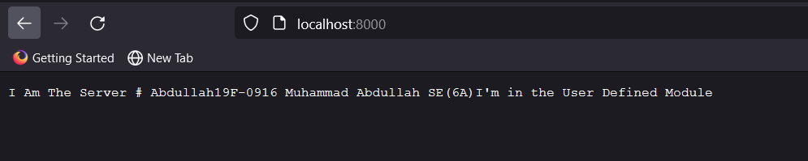

Task 6

Task 7

Main Single Point of Execution:

Task 8

Main Execution:

